Assignment #1

Task 1 – Webpage that shows my name from EC2

1. Ec2 Dashboard

1. Creating EC2

1. Access & Install Apache server on instance

1. Create index.html file

1. Start httpd service

1. Access the site.

Task 2 – Simple API with lambda function URL

Lambda URL: <https://ppnhhiplr5eswdfxxytdescnii0npnux.lambda-url.us-east-1.on.aws/>

1. Access Lambda Dashboard

1. Create a lambda function

1. Lambda is created

1. Define the API details

1. Access the API response

Task 3 – Hosting static site on S3

LINK: <http://assignment-01-task-03.s3-website-us-east-1.amazonaws.com/>

1. Access S3 Dashboard

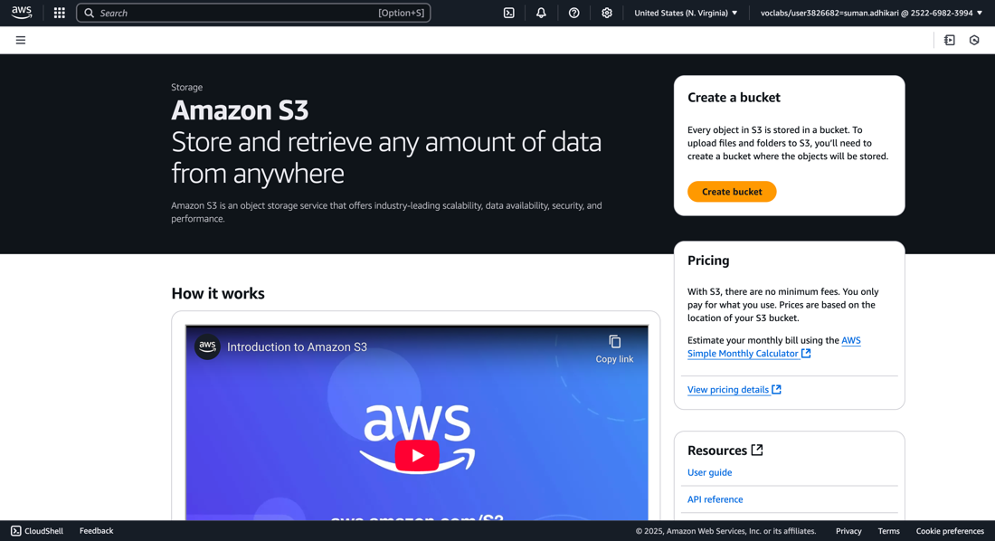

1. Create S3 bucket

1. S3 Bucket is created

1. Upload files to bucket

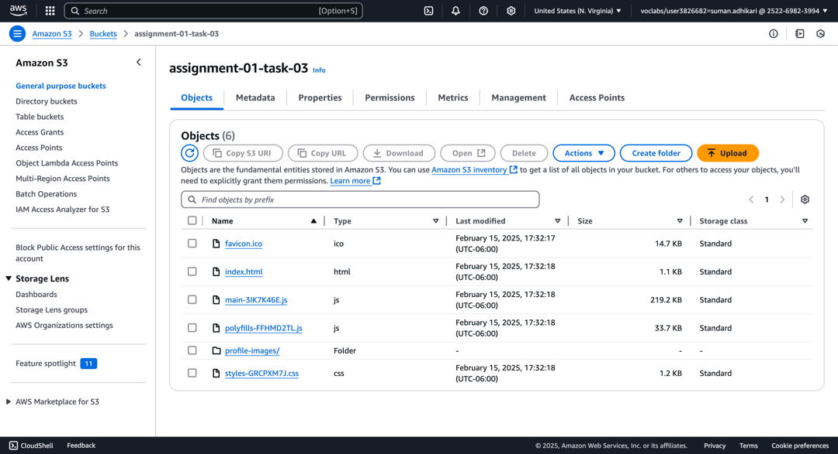

1. Update bucket policy and enable static hosting

1. Code calling Lambda API

1. Preview

